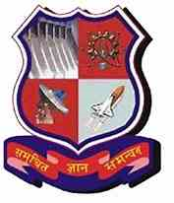 

**GOVERNMENT ENGINEERING COLLEGE GANDHINAGAR**

**(Approved by AICTE, Affiliated to GTU)**

**Sector -28 –382028, Gandhinagar**

**A report on**

**“Dynamic Traffic Management System”**

**Subject**

**Project - 1**

**Semester - VII**

**Computer Engineering**

**By**

**Team No. 93563**

|  |  |
| --- | --- |
| **Name of Student** | **Enrollment No.** |
| **Maunish Dave** | **170130107020** |
| **Shrey Panchal** | **170130107057** |
| **Gokhale Chaitanya** | **170130107028** |

**Under Guidance of**

**Prof. J.S Dhobi**

**Academic year**

**2020-2021**



Department of Computer Engineering

GOVERNMENT ENGINEERING COLLEGE GANDHINAGAR

(Approved by AICTE, Affiliated to GTU)Sector -28 –382028, Gandhinagar

**CERTIFICATE**

This is to certify that the project report entitled **“Dynamic Traffic Management System”** is submitted by Team No.93565 under the guidance of Prof J.S. Dhobi partial fulfillment of the Bachelor of Engineering in Computer Engineering from Gujarat Technological University during the academic year 2020-2021.

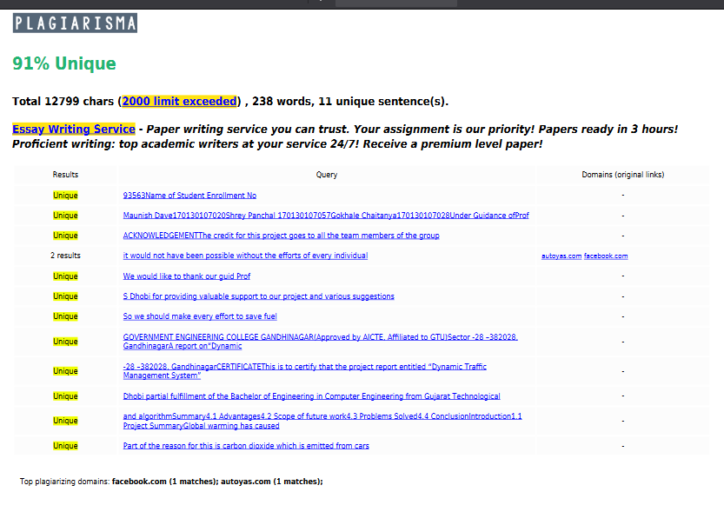

**ACKNOWLEDGEMENT**

The credit for this project goes to all the team members of the group; it would not have been possible without the efforts of every individual.

We would like to thank our guid **Prof. J.S Dhobi** for providing valuable support to our project and various suggestions.

**Maunish Dave[170130107020]**

**Shrey Panchal [170130107057]**

**Chaitanya Gokhale[170130107028]**

**INDEX**

|  |
| --- |
| 1. **Introduction** |
| 1.1 Project Summary |
| 1.2 Aim of Project |
| 1.3 Problem specifications |
| 1.4 Literature Review |
| 1.5 Materials/ Tools Required |

|  |
| --- |
| 1. **Design Engineering Canvases** |
| 2.1 AEIOU Summary Framework |
| 2.2 Empathy Canvas |
| 2.3 Ideation Canvas |
| 2.3 Product Development Canvas |

|  |
| --- |
| 1. **Workflow** |
| 3.1 Making Object Detection Model |
| 3.2 Making Simulation of a small city |
| 3.3 Idea of algorithm |
| 3.4 Improving our simulation and algorithm |

|  |
| --- |
| 1. **Summary** |
| 4.1 Advantages |
| 4.2 Scope of future work |
| 4.3 Problems Solved |
| 4.4 Conclusion |

**Introduction**

**1.1 Project Summary**

Global warming has caused a huge impact on our planet. Part of the reason for this is carbon dioxide which is emitted from cars using gasoline. So we should make every effort to save fuel. Survey says that most of the people do not turn off their car or bike engine while waiting at the traffic lights. Furthermore, mismanagement of the traffic signals causes traffic jams which leads to more pollution. So we made a smart traffic lights system using the help of object detection and reinforcement learning to not only avoid traffic jams on intersections but also reduce the amount of time people have to wait on signals.

**1.2 Aim of Project**

The main aim of our project is to reduce the amount of waiting time on traffic signals using machine learning. We will do this with the help of reinforcement learning.

The idea of the project is to make a simulation which replicates a normal city and then train a reinforcement learning model on the simulation which will get rewarded when it saves time. The only information the model has is the number of cars present on every intersection.

**1.3 Problem Specification**

The manual management of the traffic lights is not efficient enough; it causes traffic jams and sometimes the waiting time is too long even if there are no vehicles on the road.

So we need a system which could smartly assess the current traffic situation and makes decision based on that.

**1.4 Literature Review**

We referred to the documentation of YOLO for object detection.

We referred to 5 patents from google patents database which were related to our project.

We referred to various surveys regarding current traffic lights management system.

**1.5 Materials / Tools required**

* **Python**
* **Pytorch**
* **Albumentations**
* **Opencv**
* **Google Colab (for gpu)**

**Design Engineering Canvas**

**2.1 AEIOU Summary Framework**

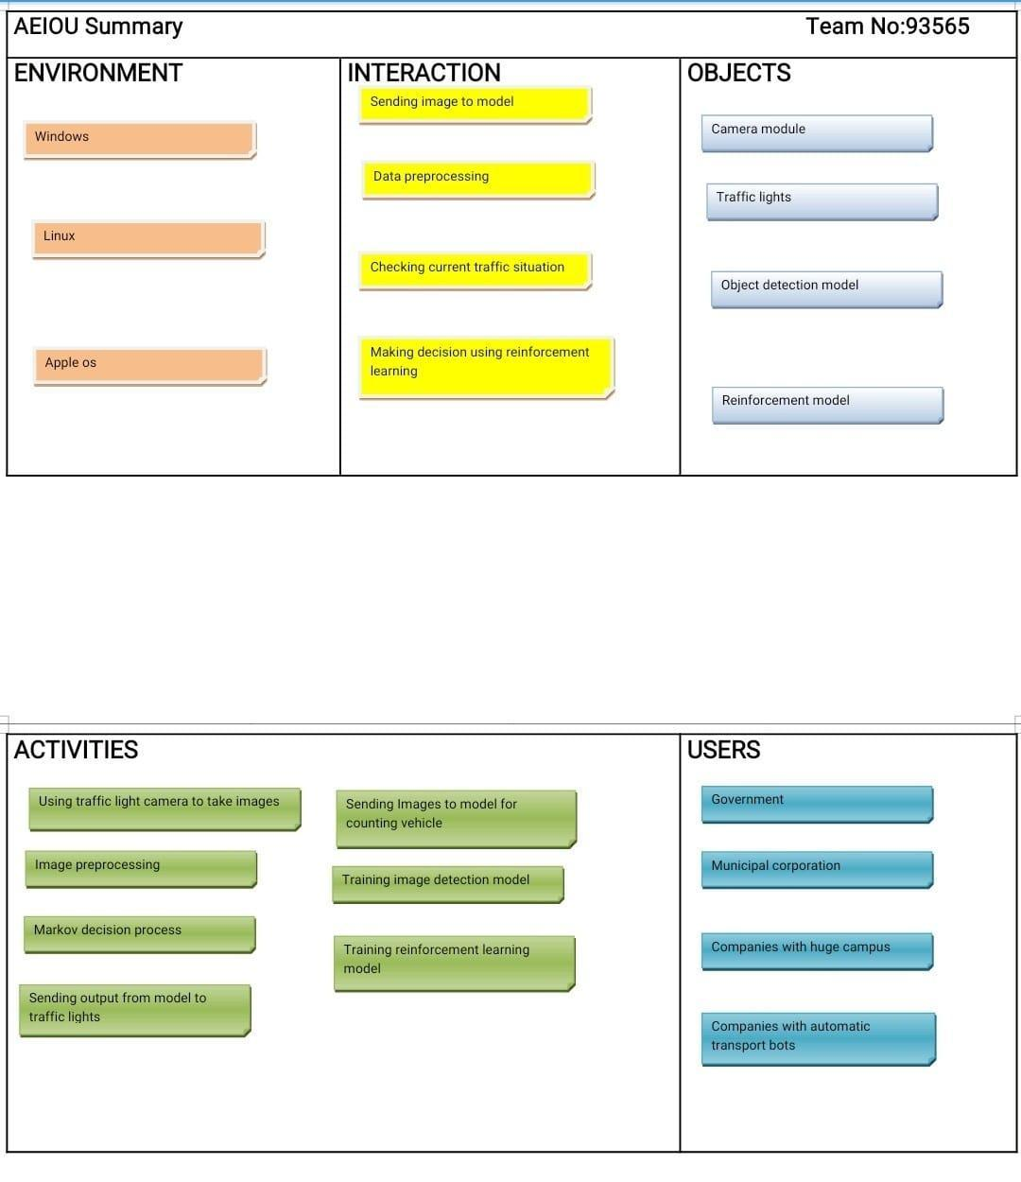

* The full form of AEIOU is Activity Environment Interaction Objects and Users, which explained in the above canvas.
* AEIOU is an observation tool. AEIOU framework is an examination tool to help interpret obser-vation by practices in the field.
* Its primary functions are to code data and to develop building blocks of models that will ultimately indicate the objectives and needs of users.In this canvas we covered a summary of AEIOU canvases.
* Activity of the project is using a traffic light camera to take images, image processing, markov discussion process, sending image to model, getting output from the model, training reinforcement learning model.
* Environment in which this can be used is windows, linux, mac OS. Our system mainly interacts with the model i.e sending images to model, image processing and making decisions using reinforcement learning.
* Objects used for our project are camera module, traffic lights, Object detection model, reinforcement model.
* And our Users are Government, municipal corporations, companies having huge campuses and companies with automatic transport bots.

**2.2 Empathy canvas**

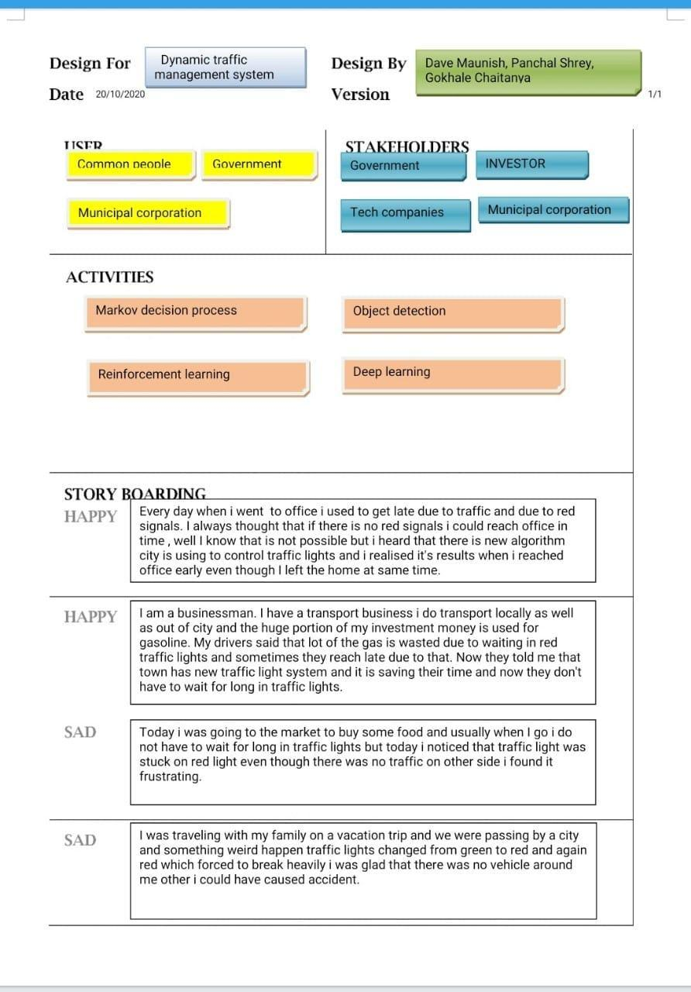

* Empathy Map is the canvas where a designer has to observe and understand the emotional need of the user and on the basis of empathy of the user he will think of the solution.
* It is used to deliver a better user experience of a system/service/product. The discussion will be centered on what was observed and what can be inferred about these users’ group belief and emotions.
* An Empathy Mapping is a tool which helps us to summarize our observations and take out unex-pected ideas with no restriction and any bound.
* Here User is who is going to use our solution, research or analysis.
* In this stage, we find various users which are directly or indirectly related to our project.
* Stakeholder is a person, group or organization with on interest in our project.
* Empathy Canvas tells us about the users, activity and stockholders.
* Users for our project are common people, government and municipal corporations.
* Activity done by the system is markov decision process, object detection, reinforcement learning and deep learning.
* And our stockholders are government, investors, tech companies and municipal corporations.
* Also the story written in the above canvas is related to real people’s life and problems faced by them in their day to day life.

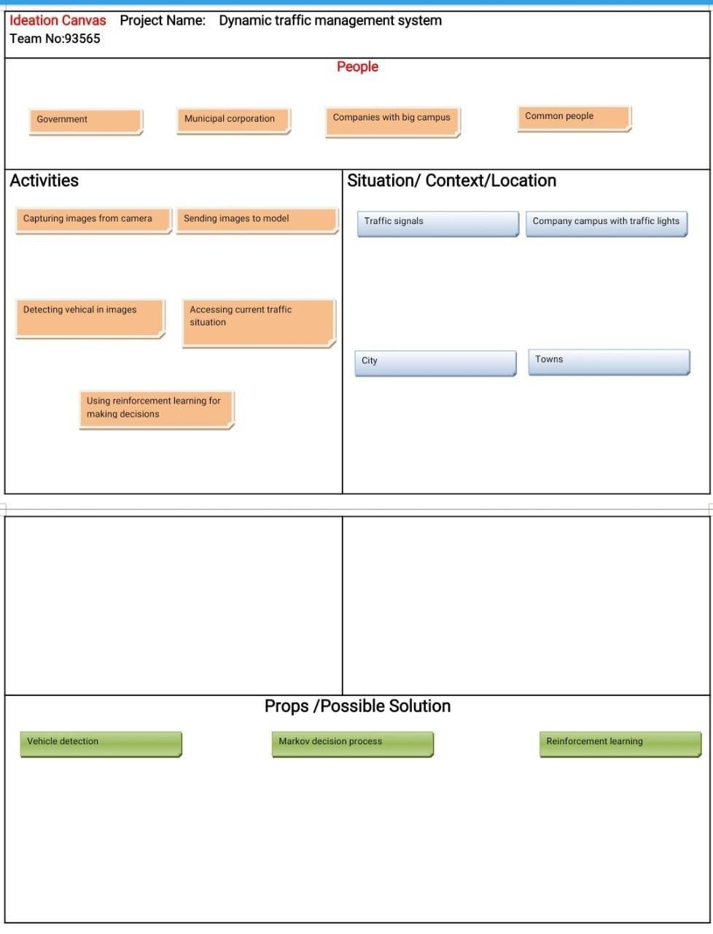**2.3 Ideation Canvas**

* Ideation Canvas where first we started with people, where we simply thought about the people for whom we want to solve the problem.Then list out whatever activity every segment of people does.
* Then thought for context/loca-tion/situation and finally for possible solutions.Ideation is the creative process of generating, developing and communicating new ideas, where an idea is understood as a basic element of thought that can be visual, concrete or abstract. Ideation compro-mises all stages of the thought cycle, from innovation, to development, to actualization.
* As such, it is an essential part of the design process, both in education and practice.
* An Ideation canvas is a sheet where ideas can be stretched into any limits or dimensions. Our idea-tion Canvas is as given below...
* Ideation canvas tells us about people, activity, location where our system can be used and porbs of our system. People who can use our project are the Government, municipal corporation, company having a huge campus and common people.
* Activities done by our system are capturing images from cameras, sending images to models, detection of vehicles, accessing current traffic situations and using reinforcement models for making decisions.
* Situations where our system can be used are traffic signals, campus with traffic lights, city and town.

**2.4 Product development Canvas**

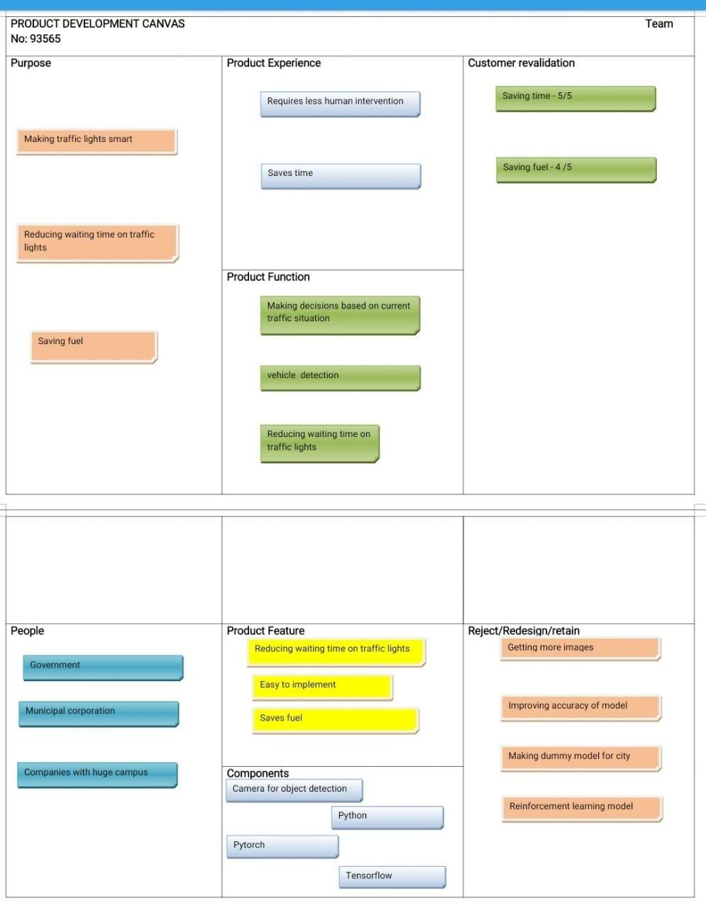

* This exercise is meant for giving strategic orientation to the project of each team so that it achieves its true goal as defined by previous canvas exercises.
* This exercise is more about developing strategy for the proposed product/solution design, after the team has successfully attempted the ideation process and has incorporated inputs from all Stakeholders.
* Product development canvas tells about the final product of our project. It includes purpose, people, product experience, product functions, product feature, components and redesign.
* Purpose of our project is making traffic lights smart, reducing the time of waiting on traffic signals and also saving the fuel wasted over traffic signal .
* Product experiences require less human intervention and save time for people. Product functions are making decisions based on current traffic situations, detecting vehicles and reducing waiting time at traffic signals.
* People who can use our system are the government, municipal corporation, company having a huge campus.
* Product features are saving time at traffic signals, easy to implement and saves fuel. Components used for the project are camera for object detection, python, pytorch, tensorflow.
* Redesign of the project can be done by getting more images, improving accuracy of model, making dummy model for city and reinforcement learning model.

**3.1 Making of Object Detection Model**

* We needed to build a vehicle detection model to count the number of cars on the intersection.
* We first read about the R-CNN model and tried to train the model.
* It was very slow and inaccurate.
* We first trained an Efficient-Det model but the model was difficult to train.
* We were not having enough GPU power to train the model.
* We also tried to use more images which were difficult to find but there was no increase in accuracy.
* Then we read about the YOLO object detection model and we tried to train it on various car images.
* Not only was it more accurate but also faster than previous models.

**3.2 Making of a simulation of small city.**

* It is not possible to run and test algorithms in real time.
* So we need to develop a simulation of a small city on which we can test our algorithms.
* So first we tried to search for various different python modules for making simulations.
* We found few but AnyLogic was good one and It had a good python API
* We tried to improve the accuracy of the YOLO model but GPU power we had was not enough.

**3.3 Idea of algorithms**

* At first we were going to use a manual algorithm for making decision on algorithms.
* But It was difficult to come up with the algorithm as there were too many cases to take in account.
* So we started looking for machine learning algorithms which we can use.
* We tried to use normal Deep learning algorithms but as this is a non-supervised problem there was no way to train it.
* Then we thought about using Reinforcement Learning. We read various papers on RL and found that it can be used for our problem.
* We decided to create RL models on a different problems to learn more about it.

**3.4 Improving our simulation and algorithm**

* So the last thing to do was improve our simulation and improve our model.
* We created a bigger simulation of the city.
* We needed to train our model quickly so we created dummy simulation which has same dimensions as real simulation.
* We decided upon the reward function for our Reinforcement learning algorithm and tested it on real simulation.

**4.1 Advantages**

* This project was built because there was no algorithm which could manage traffic lights.
* We used Reinforcement Learning which is a unique was of solving this problem and it is very efficient.
* It helps to reduce the amount of time people have to wait on traffic lights.
* And it also saves fuel as people do not have to wait long on traffic lights.
* It also avoids traffic jams.

**4.2 Scope of future work**

* In future there will be self-driving cars so we can communicate directly with car to tell it when to start decelerating so it do not have to break suddenly and that saves fuel.
* We know beforehand the destination of the car so we can adjust our traffic lights system to take that into account and use it as additional information.
* We can improve system to give higher priority to emergency vehicles.

**4.3 Problems solved**

* There was no smart decision being made behind which lights on current crossing will reduce waiting time and avoid traffic jams.
* Our algorithm tries to do it by making use of the power of Reinforcement Learning and object detection.

**4.4 Conclusion**

It is our responsibility to make this world a better place using smart technology. Traffic lights have been around for so long but now it needs

improvement . This is our approach to take traffic lights to next level and make them smart traffic lights.

**5.1 PPR1 Details**

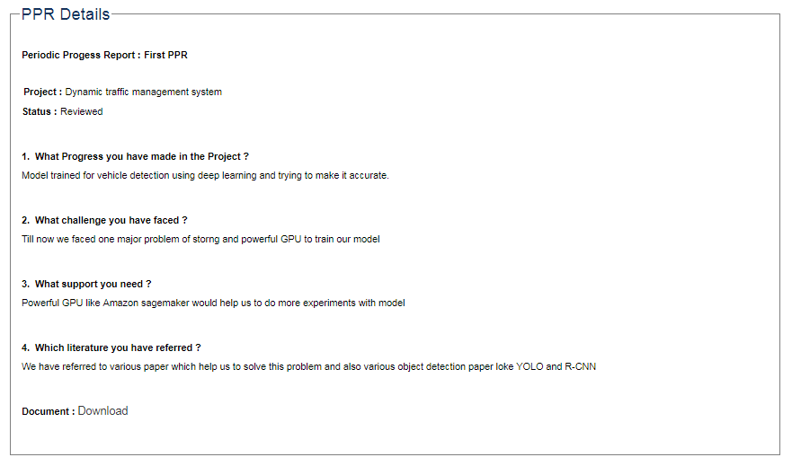

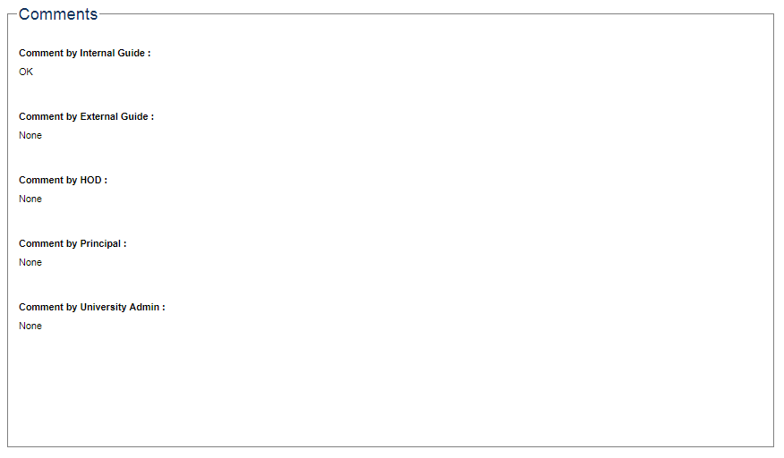

**5.2 PPR2 Details**

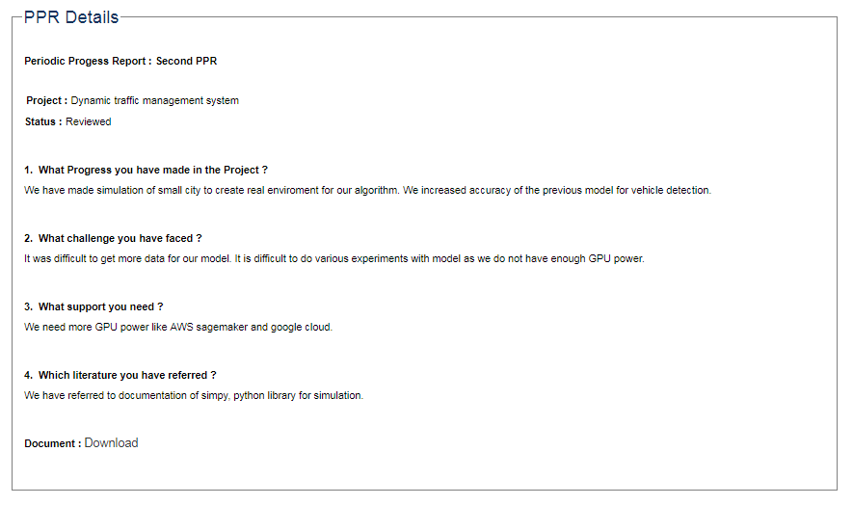

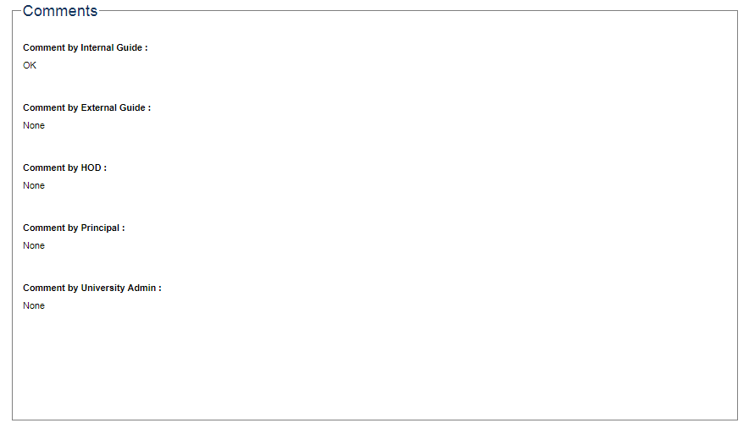

**5.3 PPR3 Details**

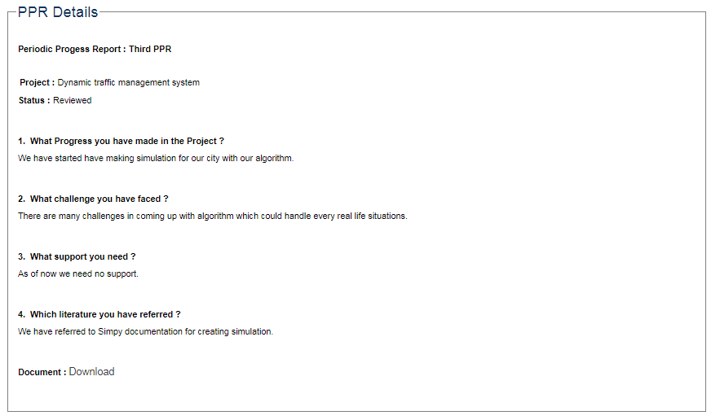

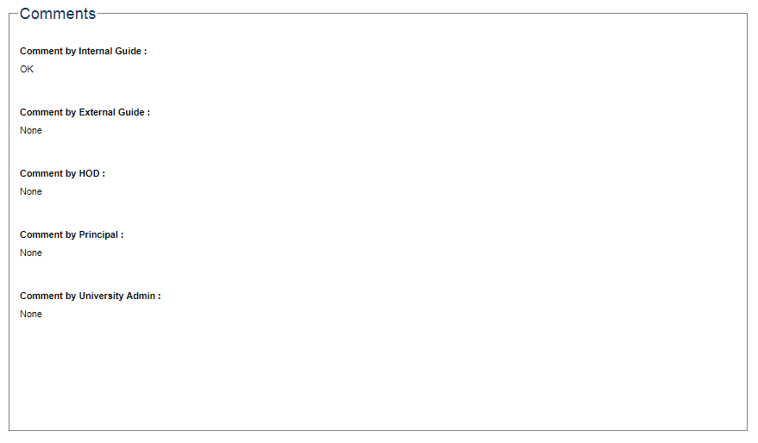

**5.4 PPR4 Details**

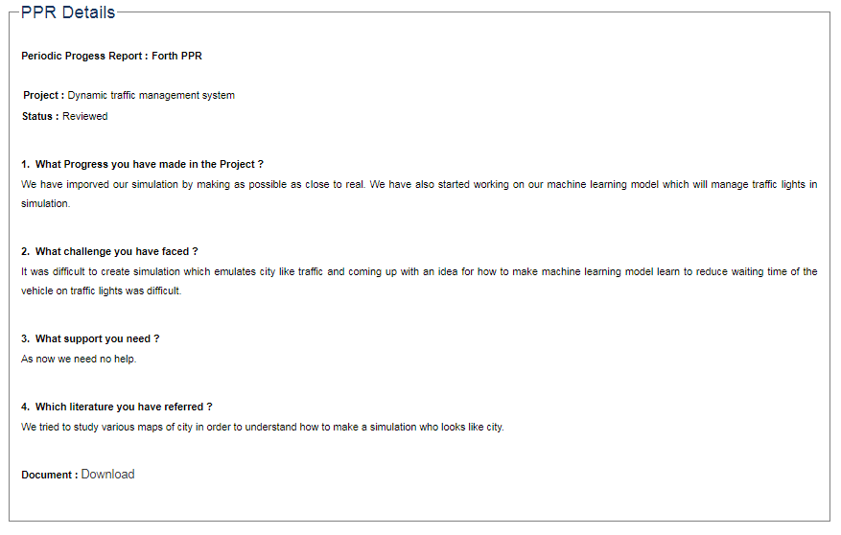

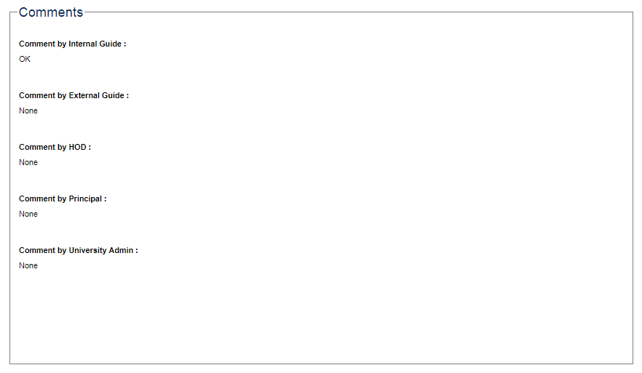

**References**

Yolo paper: <https://arxiv.org/pdf/1506.02640.pdf>

Anylogic: <https://www.anylogic.com/>

Reinforcement Learning Survey:<https://arxiv.org/pdf/cs/9605103.pdf>

Traffic light prediction system: <https://patents.google.com/patent/US7187301?oq=traffic+lights>

Automatic Vehicle detection based on deep learning[:https://patents.google.com/patent/CN105184271A/en?oq=vehicle+detection+machine+learning](https://patents.google.com/patent/CN105184271A/en?oq=vehicle+detection+machine+learning)

Multi-agent-reinforcement learning for integrated and networked traffic controller:

<https://patents.google.com/patent/CA2859049A1/en?oq=reinforcement+learning+for+traffic+lights+management>

Decentralised autonomic system and method for traffic control environment:

<https://patents.google.com/patent/US9685080?oq=traffic+light+management+system>